SUMMARY OF COMMUNITY WELLNESS AND RECOVERY FORUMS
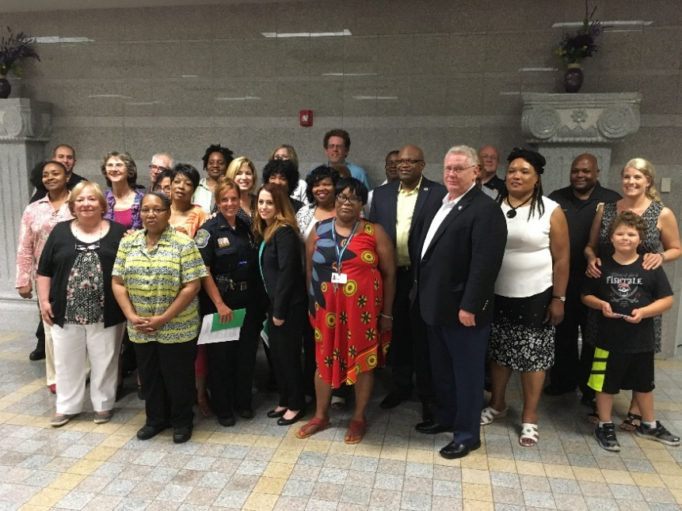
EVENT OVERVIEW
Over the course of 6 months from February through July 2017, members of the CT Recovery and Wellness Coalition (CRWC) organized a series of Community Conversations for improving crisis care for people struggling with mental health and/or addiction issues. CWRC is an effort supported by the Department of Mental Health and Addiction (DMHAS) with funding from the Substance Abuse and Mental Health Services Administration’s (SAMHSA) Bringing Recovery Supports to Scale Technical Assistance Center Strategy (BRSS TACS) grant. CWRC’s Vision: Connecticut communities will support people in their time of need in a manner that respects individuals’ culture, dignity, hopes, and rights.

The project was led by Cross Street Training and Academic Center (CSTAC), a faith-based organization associated with Cross Street AME Zion Church. Project leaders hoped to enhance the role faith-based organizations, church leaders, persons in recovery and community advocates as essential partners in Connecticut’s efforts to improve and sustain crisis response, intervention, and treatment.
Conversations were structured as facilitated dialogues led by members of the CWRC. The Conversations offered opportunities for people from different communities and varied perspectives to learn from each other, identify resources, and develop strategies for enhancing crisis care in Connecticut communities. They were hosted by Cross Street AME Zion Church in Middletown and engaged 70 different participants over the course of the six sessions (average of 23 participants per session). Participants included individuals in recovery from mental health or addiction problems (30%), family members (31%), representatives of the faith community (20%), behavioral health providers (22%), and law enforcement (5%). Of note was the coming together of three Ministerial Alliances from Middletown, Hartford and New Britain for addressing behavioral health and community issues. Participants reported that they came to learn, connect with others, and help their communities. Each Conversation followed an arc starting with making connections and an introduction to the topic. We continued to delve deeper into the topic/issue and how services help. We explored related challenges and how we respond to them. Finally, we identified actions steps we can take to improve care in in our communities.

WHAT WE LEARNED
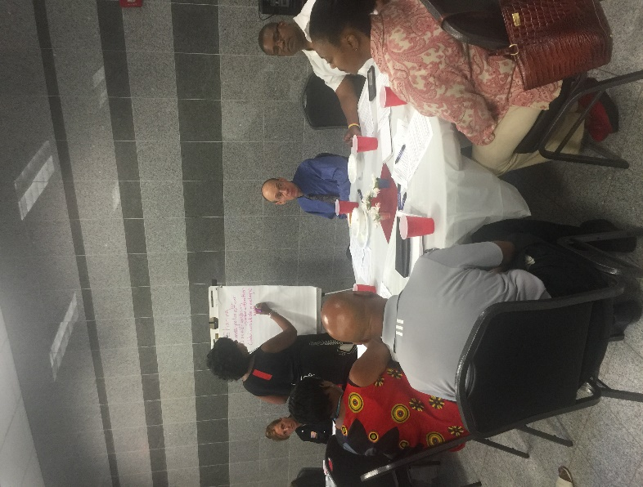
Participants joined the discussion for a variety of reasons. Most wanted to learn more about the topic and resources. Several shared personal experiences and attended with intention to help others. Many had experience with seeking help for themselves or a loved in crisis. Participants saw crisis response as multifaceted and were looking for caring communities where people can reach out and recover together. Representatives of the faith community (from primarily Black Christian churches) wanted to start or further develop recovery supports within their churches, but also wanted to be acknowledged for the work they are already doing.
Participants expressed a desire for more community outreach to combat stigma and promote greater access to resources. We need new, creative approaches to reach the people who need to hear about these issues, but are who are not coming to our forums. We need to understand addiction as a disease for which there are a variety of treatment approaches and many paths to recovery. We need to affirm and promote more community-based and natural supports. Mental health and addiction issues have an impact on the entire family, not just the struggling person, so we need communities to be more supportive and understanding of all those affected. We need the treatment system to understand that medication is not the only, nor even the right solution for many people. Inaccurate diagnoses and issues with prescribed medications (side effects, cost, ineffective) were discussed as common problems. We need rapid access to care and a coordinated continuum of care that includes prevention, intervention, and follow-up post crisis.
A full session was devoted to understanding culture and cultural differences. Participants willingly explored their own sources of bias and discussed many aspects of difference beyond language, ethnicity, and age. Making a connection and helping other people feel safe, valued, and respected were considered most important even when cultural or language differences exist between individuals and helpers. It is still critically important to recruit and train more persons of color for work in behavioral health (the need to re-invigorate the DMHAS-funded Project for Addiction Cultural Competency Training (PACCT) program was mentioned several times), ensure access to interpretation and translation where needed, and advocate for more peer support and Community Health Workers (CHWs) in all aspects of healthcare.
One session was devoted to pastoral care and the need to better integrate pastoral care into the full continuum of services available to people struggling with mental health or addiction issues. Participants discussed factors that divide the church from the health community and why the church’s resources for healing are relegated to the outskirts of behavioral health system. On one hand, churches are viewed as places of safety, kindness, sensitivity, and compassion. On the other hand, church people recognized they can come across as judgmental, exclusive, and only concerned with saving souls. Pastors were encouraged to 1) conduct asset mapping within their churches to better understand internal resources and community needs, 2) develop or enhance health ministries, and 3) become knowledgeable and shore up community partnerships to become a hub that connects congregants with external resources as needed.
The last session was devoted to building coalitions with law enforcement. Police officers described the tools available for responding to mental health and addiction crises. Officers shared their frustration with their role as first responders and the lack of referral options for people who need help. Participants discussed conflicting roles of law enforcement – often called upon as a show of force, or “the muscle” in crisis situations, but also called upon to exercise restraint, sensitivity, and patience in situations of mental health crisis. All participants agreed about the need for more training, communication, coalition building, advocacy, and resource development.

RECOMMENDATIONS
“The intensity of involvement and level of conversation was outstanding.
Sooo glad I came!”
At the beginning and end of each session, participants completed surveys that provide detail about the demographics of the group, reasons for participating, and offer feedback about the sessions and suggestions for improvement. (See Appendix on page 5 for greater detail). All but one participant rated their experiences with the Conversations as good or very good. Most indicated their participation had a positive impact on their understanding of healthcare, knowledge of resources, and ability to talk about mental health and addiction. Participants most appreciated meeting new people, hearing from experts, and sharing their own voices. Suggestions for future sessions included: meeting more often, offering Conversations in more locations and during the day, shorter sessions, more visuals, and using the learnings to spur action.
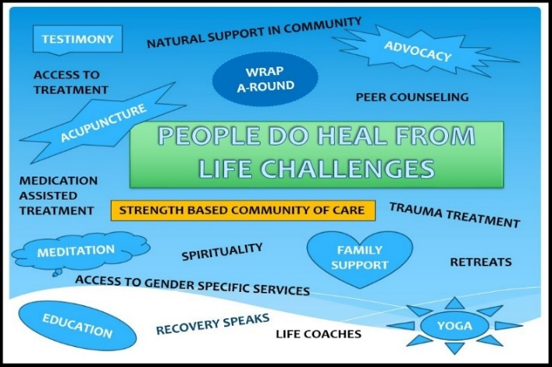
At the end of each session, participants were asked to imagine a world in which their various ideas about living in responsive, caring communities could become a reality. They were asked to brainstorm what would be some of the first steps needed to get there and select two of their most “doable” ideas for further action.

The following ideas represent opportunities for further action by the CWRC, , state agencies, policy makers, and leaders at the state and local level:
- Educate:
  - Conduct community outreach – identify additional partners and get them to the table.
  - Convene key stakeholders in organizing a “proactive citizenry” identifying and responding to community issues. Be intentional about engaging diverse groups and faith communities. Raise funds and provide ongoing training for community coalition work.
  - Conduct workplace trainings about how to recognize and respond to sign of mental distress.
  - Counteract stigma with more conversations/education with people in recovery as “living proof” participants. Use radio and public service announcements to reach wider audiences.
  - Conduct more training for early intervention with children at risk due to trauma or abuse.
  - Infiltrate existing “mentoring groups” and the companies that donate to them (Boys and Girls Clubs, Big Brother/Big Sisters, Boy Scouts, Girl Scouts) with protective information for children, youth and their families.
- Advocate:
  - Use legislative hearings and breakfasts to influence policy makers.
  - Work with NAMI to reach more families with training and support. Ensure families are included in treatment with their loved ones when appropriate.
  - Require hospitals and insurance companies to make follow-up calls to patients after discharge.
- Build Resources:
  - Identify and obtain new sources of funding for services. Identify and direct funding to programs that work.
  - Build or enhance on-line resource navigation assistance tools. Tailor on-line and hardcopy resource tools for use by culturally diverse audiences.
  - Conduct asset mapping in local churches and convene with emergency response teams and other church alliances to share ideas.
  - Move churches into more prevention roles, i.e., strengthening, resilience, positive behaviors.
    - Develop respite options in churches
    - Establish or enhance health ministries in churches.
- Workforce Development:
  - Increase the pool of mental health and addiction specialists who are persons of color or at least culturally competent.
  - Develop more peer support, faith-based, and support groups for children coming from substance/alcohol affected environments.
  - Expand use of Recovery Coaches in hospitals. Identify other places where Recovery Coaches would be helpful (schools, Mobile Crisis Teams, walking the beat with police officers, etc.).
  - Recruit, certify, and employ more Community Health Workers.
NEXT STEPS
Participants hope their work and insights will lead to positive change and their recommendations will be used to influence policy and policy makers at the state and local level. Interest was sparked in other areas of our region and resulted in plans to lead two more series of coalition building Conversations this fall in Hartford and North Central Connecticut. In New Britain, one church stepped up its involvement with the establishment of a recovery and health ministry, led by a church member newly certified as a recovery coach. DMHAS has begun meetings with providers of Mobile Crisis services and plans to enhance their role and services. Two new initiatives, one led by DMHAS and another led by CTSAC are focused on building up the capacity of Black churches to offer recovery support services and lead advocacy efforts to address health inequities in their communities.

ACKNOWLEDGEMENTS
We would like to thank the Cross Street Training and Academic Center (CSTAC), Department of Mental Health and Addiction Services (DMHAS), the Substance Abuse and Mental Health Services Administration (SAMHSA) Bringing Recovery Supports to Scale (BRSS TAC) Technical Assistance Team, and Staff and Advisory Board members from the State Innovation Model (SIM) Consumer Advisory Board (CAB) for their financial and technical support for this project.

APPENDIX: PARTICIPANT FEEDBACK ON COMMUNITY CONVERSATIONS

In what ways were they
most helpful to you?

- Meeting new people
- Insightful, Informative
- Gained understanding
- Learned about resources
- Hearing from experts
- Input from people in recovery
- Sharing my voice
- Ideas for action
- Genuine, thoughtful, earnest conversation

